INDAS 116 Module
Prompt 1 – Claude Sonnet 5 (Medium)
Prepare a Ind AS 116 Model where i need to add the monthly rental along with interest rate implicit and generate the ROU & Lease liability on Day 0 and the share the .py file. Also refer Ind AS 116 attached herewith with front end GUI. All required third-party libraries must be detected and installed automatically during the first execution and user can see the installation log during installation. Code should be modular, reusable, and suitable for long-term maintenance in a professional Chartered Accountancy practice

PY Code File
#!/usr/bin/env python3
"""
Ind AS 116 — Lease Accounting Model (Single-File GUI Edition)
==============================================================
Self-contained version: no separate package folder required. Just
save this one file anywhere and run:

python 116v1.py

On first run (or whenever a required package is missing), a live
installation log window is shown while pandas / openpyxl /
python-dateutil are installed automatically. On later runs, with
dependencies already present, it starts straight into the main window.

Sections in this file (kept clearly separated for maintainability —
if this suite grows further, each section below can be split back
into its own module: bootstrap / models / engine / excel_export / gui):
1. Bootstrap — dependency detection & auto-install with live log
2. Models — LeaseInputs / LeaseResult data structures
3. Engine — all Ind AS 116 calculations (no I/O)
4. Excel — workbook export
5. GUI — Tkinter desktop application
6. main() — entry point
"""

from __future__ import annotations

import importlib
import json
import queue
import subprocess
import sys
import threading
import tkinter as tk
from dataclasses import dataclass
from datetime import date, datetime
from tkinter import filedialog, messagebox, ttk
from typing import Any, Callable, Dict, List, Tuple

# =====================================================================
# 1. BOOTSTRAP — dependency detection & auto-install with live log
# =====================================================================

LogFn = Callable[[str], None]

REQUIRED_PACKAGES = {
"pandas": "pandas",
"openpyxl": "openpyxl",
"dateutil": "python-dateutil",
}

def check_missing() -> List[str]:
missing = []
for import_name, pip_name in REQUIRED_PACKAGES.items():
try:
importlib.import_module(import_name)
except ImportError:
missing.append(pip_name)
return missing

def _run_pip(args: List[str], log: LogFn) -> int:
process = subprocess.Popen(
[sys.executable, "-m", "pip"] + args,
stdout=subprocess.PIPE,
stderr=subprocess.STDOUT,
text=True,
bufsize=1,
)
assert process.stdout is not None
for line in process.stdout:
log(line.rstrip("\n"))
process.wait()
return process.returncode

def install_package(pip_name: str, log: LogFn) -> bool:
log(f"--- Installing {pip_name} ---")
code = _run_pip(["install", pip_name], log)
if code == 0:
log(f"[OK] {pip_name} installed successfully.\n")
return True

log(f"[WARN] Standard install failed (exit code {code}). "
f"Retrying with --break-system-packages ...")
code2 = _run_pip(["install", pip_name, "--break-system-packages"], log)
if code2 == 0:
log(f"[OK] {pip_name} installed successfully (system-managed override).\n")
return True

log(f"[ERROR] Failed to install {pip_name} (exit code {code2}). "
f"Please install it manually: {sys.executable} -m pip install {pip_name}\n")
return False

def ensure_dependencies(log: LogFn) -> Tuple[bool, List[str]]:
log("Checking required third-party packages ...")
missing = check_missing()

if not missing:
log("All required packages are already installed. Continuing.\n")
return True, []

log(f"Missing packages detected: {', '.join(missing)}")
log("Beginning automatic installation. This happens once per machine.\n")

failed = []
for pip_name in missing:
if not install_package(pip_name, log):
failed.append(pip_name)

if failed:
log(f"\n[ATTENTION] Could not install automatically: {', '.join(failed)}")
log("The application may not function correctly until these are installed manually.\n")
return False, failed

log("All dependencies are ready.\n")
return True, []

# =====================================================================
# 2. MODELS — LeaseInputs / LeaseResult
# (pandas is imported lazily inside functions that need it, so this
# file can be parsed/started even before pandas is installed —
# the install step above runs first.)
# =====================================================================

@dataclass
class LeaseInputs:
lease_commencement_date: date = date.today()
lease_term_months: int = 60
monthly_rental: float = 100000.0
rent_escalation_pct: float = 0.0
escalation_frequency_months: int = 12
payment_timing: str = "advance"
interest_rate_implicit_annual: float = 0.0
incremental_borrowing_rate_annual: float = 0.10
initial_direct_costs: float = 0.0
lease_incentives_received: float = 0.0
prepaid_rentals_at_commencement: float = 0.0
restoration_cost_estimate: float = 0.0
restoration_cost_discount_rate_annual: float = 0.0
residual_value_guarantee: float = 0.0
purchase_option_price: float = 0.0

def validate(self) -> None:
errors = []
if self.lease_term_months <= 0:
errors.append("Lease term (months) must be a positive integer.")
if self.monthly_rental < 0:
errors.append("Monthly rental cannot be negative.")
if self.payment_timing not in ("advance", "arrears"):
errors.append('Payment timing must be "advance" or "arrears".')
if self.interest_rate_implicit_annual == 0 and self.incremental_borrowing_rate_annual <= 0:
errors.append(
"Either the Interest Rate Implicit in the Lease or the "
"Incremental Borrowing Rate must be a positive rate."
)
if self.escalation_frequency_months <= 0:
errors.append("Escalation frequency (months) must be positive.")
if errors:
raise ValueError("Invalid lease inputs:\n- " + "\n- ".join(errors))

def to_dict(self) -> Dict[str, Any]:
d = self.__dict__.copy()
d["lease_commencement_date"] = self.lease_commencement_date.isoformat()
return d

@classmethod
def from_dict(cls, d: Dict[str, Any]) -> "LeaseInputs":
d = dict(d)
if isinstance(d.get("lease_commencement_date"), str):
d["lease_commencement_date"] = date.fromisoformat(d["lease_commencement_date"])
return cls(**d)

@dataclass
class LeaseResult:
rate_source: str
annual_rate_used: float
monthly_rate: float
lease_liability_day0: float
rou_asset_day0: float
summary: Dict[str, float]
payment_schedule: "Any" # pandas.DataFrame (typed loosely to avoid a hard import at module load)
amortisation_schedule: "Any"
depreciation_schedule: "Any"

# =====================================================================
# 3. ENGINE — all Ind AS 116 calculations
# =====================================================================

class LeaseEngine:
"""
Ind AS 116 (Leases) — lessee initial recognition:
Lease Liability = PV of unpaid lease payments, discounted at
the Interest Rate Implicit in the Lease if
readily determinable, else the Incremental
Borrowing Rate.
ROU Asset (cost) = Initial Lease Liability
+ payments made at/before commencement
- lease incentives received
+ initial direct costs
+ PV of restoration/dismantling costs.
"""

def __init__(self, inputs: LeaseInputs):
inputs.validate()
self.inputs = inputs

def monthly_discount_rate(self) -> Tuple[float, float, str]:
i = self.inputs
if i.interest_rate_implicit_annual and i.interest_rate_implicit_annual != 0:
annual_rate = i.interest_rate_implicit_annual
source = "Interest Rate Implicit in the Lease (IRIL)"
else:
annual_rate = i.incremental_borrowing_rate_annual
source = "Incremental Borrowing Rate (IBR)"
monthly_rate = (1 + annual_rate) ** (1 / 12) - 1
return monthly_rate, annual_rate, source

def build_payment_schedule(self):
import pandas as pd
from dateutil.relativedelta import relativedelta

i = self.inputs
n = i.lease_term_months
rows = []
current_rent = i.monthly_rental

for m in range(1, n + 1):
if i.rent_escalation_pct and m > 1 and (m - 1) % i.escalation_frequency_months == 0:
current_rent = current_rent * (1 + i.rent_escalation_pct)

if i.payment_timing == "advance":
payment_date = i.lease_commencement_date + relativedelta(months=m - 1)
discount_periods = m - 1
else:
payment_date = i.lease_commencement_date + relativedelta(months=m)
discount_periods = m

rows.append({
"Month": m,
"Payment Date": payment_date,
"Lease Payment (INR)": round(current_rent, 2),
"Discount Periods (months)": discount_periods,
})

df = pd.DataFrame(rows)
extra = i.residual_value_guarantee + i.purchase_option_price
if extra:
df.loc[df.index[-1], "Lease Payment (INR)"] += extra
return df

def compute_day0(self, payment_df, monthly_rate: float):
i = self.inputs
pv_factors = 1 / (1 + monthly_rate) ** payment_df["Discount Periods (months)"]
payment_df = payment_df.copy()
payment_df["PV Factor"] = pv_factors.round(6)
payment_df["Present Value (INR)"] = (
payment_df["Lease Payment (INR)"] * payment_df["PV Factor"]
).round(2)

lease_liability_day0 = float(payment_df["Present Value (INR)"].sum())

restoration_rate = (
i.restoration_cost_discount_rate_annual
or i.interest_rate_implicit_annual
or i.incremental_borrowing_rate_annual
)
restoration_monthly_rate = (1 + restoration_rate) ** (1 / 12) - 1 if restoration_rate else 0
pv_restoration = 0.0
if i.restoration_cost_estimate:
pv_restoration = i.restoration_cost_estimate / (
(1 + restoration_monthly_rate) ** i.lease_term_months
)

rou_asset_day0 = (
lease_liability_day0
+ i.prepaid_rentals_at_commencement
+ i.initial_direct_costs
- i.lease_incentives_received
+ pv_restoration
)

summary = {
"Lease Liability at Day 0 (INR)": round(lease_liability_day0, 2),
"Add: Prepaid rentals before commencement (INR)": round(i.prepaid_rentals_at_commencement, 2),
"Add: Initial direct costs (INR)": round(i.initial_direct_costs, 2),
"Less: Lease incentives received (INR)": round(i.lease_incentives_received, 2),
"Add: PV of restoration/dismantling cost (INR)": round(pv_restoration, 2),
"Right-of-Use (ROU) Asset at Day 0 (INR)": round(rou_asset_day0, 2),
}
return payment_df, lease_liability_day0, rou_asset_day0, summary

def build_amortisation_schedule(self, payment_df, lease_liability_day0: float, monthly_rate: float):
import pandas as pd

i = self.inputs
rows = []
opening = lease_liability_day0
is_advance = i.payment_timing == "advance"

for _, r in payment_df.iterrows():
payment = r["Lease Payment (INR)"]
if is_advance:
balance_after_payment = opening - payment
interest = round(balance_after_payment * monthly_rate, 2)
closing = balance_after_payment + interest
else:
interest = round(opening * monthly_rate, 2)
closing = opening + interest - payment

rows.append({
"Month": r["Month"],
"Payment Date": r["Payment Date"],
"Opening Lease Liability (INR)": round(opening, 2),
"Lease Payment (INR)": round(payment, 2),
"Interest Expense (INR)": interest,
"Closing Lease Liability (INR)": round(closing, 2),
})
opening = closing

return pd.DataFrame(rows)

def build_depreciation_schedule(self, rou_asset_day0: float):
import pandas as pd
from dateutil.relativedelta import relativedelta

i = self.inputs
n = i.lease_term_months
monthly_dep = round(rou_asset_day0 / n, 2) if n else 0
rows = []
nbv = rou_asset_day0
for m in range(1, n + 1):
opening = nbv
dep = monthly_dep if m < n else round(opening, 2)
closing = round(opening - dep, 2)
rows.append({
"Month": m,
"Period End": i.lease_commencement_date + relativedelta(months=m),
"Opening ROU (INR)": round(opening, 2),
"Depreciation (INR)": dep,
"Closing ROU (INR)": closing,
})
nbv = closing
return pd.DataFrame(rows)

def run(self) -> LeaseResult:
monthly_rate, annual_rate_used, rate_source = self.monthly_discount_rate()
payment_df = self.build_payment_schedule()
payment_df, lease_liability_day0, rou_asset_day0, summary = self.compute_day0(payment_df, monthly_rate)
amort_df = self.build_amortisation_schedule(payment_df, lease_liability_day0, monthly_rate)
dep_df = self.build_depreciation_schedule(rou_asset_day0)

return LeaseResult(
rate_source=rate_source,
annual_rate_used=annual_rate_used,
monthly_rate=monthly_rate,
lease_liability_day0=lease_liability_day0,
rou_asset_day0=rou_asset_day0,
summary=summary,
payment_schedule=payment_df,
amortisation_schedule=amort_df,
depreciation_schedule=dep_df,
)

# =====================================================================
# 4. EXCEL EXPORT
# =====================================================================

def export_to_excel(result: LeaseResult, output_path: str) -> None:
import pandas as pd

with pd.ExcelWriter(output_path, engine="openpyxl") as writer:
pd.DataFrame(
list(result.summary.items()), columns=["Particulars", "Amount (INR)"]
).to_excel(writer, sheet_name="Day 0 Summary", index=False)

result.payment_schedule.to_excel(writer, sheet_name="Payment Schedule & PV", index=False)
result.amortisation_schedule.to_excel(writer, sheet_name="Lease Liability Amortisation", index=False)
result.depreciation_schedule.to_excel(writer, sheet_name="ROU Depreciation", index=False)

# =====================================================================
# 5. GUI
# =====================================================================

APP_TITLE = "Ind AS 116 — Lease Accounting Model"

class InstallLogWindow(tk.Toplevel):
def __init__(self, master: tk.Tk, on_done):
super().__init__(master)
self.title("First-Run Setup — Installing Required Packages")
self.geometry("720x420")
self.on_done = on_done
self.protocol("WM_DELETE_WINDOW", lambda: None)

ttk.Label(
self, text="Preparing the application (one-time setup) ...",
font=("Segoe UI", 11, "bold")
).pack(anchor="w", padx=10, pady=(10, 4))

self.text = tk.Text(self, wrap="word", state="disabled", bg="#111", fg="#0f0",
font=("Consolas", 10))
self.text.pack(fill="both", expand=True, padx=10, pady=4)

self.continue_btn = ttk.Button(self, text="Continue", command=self._continue, state="disabled")
self.continue_btn.pack(pady=8)

self._log_queue: "queue.Queue[str]" = queue.Queue()
self._success = True
self.after(100, self._poll_queue)
threading.Thread(target=self._run_bootstrap, daemon=True).start()

def _run_bootstrap(self):
def log(line: str):
self._log_queue.put(line)
ok, failed = ensure_dependencies(log)
self._success = ok
self._log_queue.put("__DONE__")

def _poll_queue(self):
try:
while True:
line = self._log_queue.get_nowait()
if line == "__DONE__":
self.continue_btn.configure(state="normal")
if self._success:
self.after(600, self._continue)
continue
self.text.configure(state="normal")
self.text.insert("end", line + "\n")
self.text.see("end")
self.text.configure(state="disabled")
except queue.Empty:
pass
self.after(150, self._poll_queue)

def _continue(self):
self.destroy()
self.on_done()

class LeaseModelApp(ttk.Frame):
FIELDS = [
("lease_commencement_date", "Lease Commencement Date (YYYY-MM-DD)", "str", ""),
("lease_term_months", "Lease Term (months)", "int", "60"),
("monthly_rental", "Monthly Rental (INR)", "float", "100000"),
("rent_escalation_pct", "Rent Escalation per Step (%, e.g. 5 for 5%)", "float", "0"),
("escalation_frequency_months", "Escalation Frequency (months)", "int", "12"),
("payment_timing", 'Payment Timing ("advance" or "arrears")', "str", "advance"),
("interest_rate_implicit_annual", "Interest Rate Implicit in Lease (%, 0 if not determinable)", "float", "0"),
("incremental_borrowing_rate_annual", "Incremental Borrowing Rate (%)", "float", "10"),
("initial_direct_costs", "Initial Direct Costs (INR)", "float", "0"),
("lease_incentives_received", "Lease Incentives Received (INR)", "float", "0"),
("prepaid_rentals_at_commencement", "Prepaid Rentals Before Commencement (INR)", "float", "0"),
("restoration_cost_estimate", "Estimated Restoration/Dismantling Cost (INR)", "float", "0"),
("restoration_cost_discount_rate_annual", "Restoration Cost Discount Rate (%, 0 = use lease rate)", "float", "0"),
("residual_value_guarantee", "Residual Value Guarantee (INR)", "float", "0"),
("purchase_option_price", "Purchase Option Price, if reasonably certain (INR)", "float", "0"),
]

def __init__(self, master: tk.Tk):
super().__init__(master)
self.master = master
self.entries: Dict[str, tk.Entry] = {}
self.last_result = None
self.pack(fill="both", expand=True)
self._build_ui()

def _build_ui(self):
notebook = ttk.Notebook(self)
notebook.pack(fill="both", expand=True, padx=8, pady=8)
self.notebook = notebook

self.input_tab = ttk.Frame(notebook)
self.summary_tab = ttk.Frame(notebook)
self.payment_tab = ttk.Frame(notebook)
self.amort_tab = ttk.Frame(notebook)
self.dep_tab = ttk.Frame(notebook)

notebook.add(self.input_tab, text="Lease Inputs")
notebook.add(self.summary_tab, text="Day 0 Summary")
notebook.add(self.payment_tab, text="Payment Schedule")
notebook.add(self.amort_tab, text="Liability Amortisation")
notebook.add(self.dep_tab, text="ROU Depreciation")

self._build_input_tab()
for tab in (self.summary_tab, self.payment_tab, self.amort_tab, self.dep_tab):
ttk.Label(tab, text="Run the model to populate this tab.").pack(padx=20, pady=20)

def _build_input_tab(self):
canvas = tk.Canvas(self.input_tab, borderwidth=0, highlightthickness=0)
scroll_frame = ttk.Frame(canvas)
scrollbar = ttk.Scrollbar(self.input_tab, orient="vertical", command=canvas.yview)
canvas.configure(yscrollcommand=scrollbar.set)

canvas.pack(side="left", fill="both", expand=True)
scrollbar.pack(side="right", fill="y")
canvas.create_window((0, 0), window=scroll_frame, anchor="nw")
scroll_frame.bind("<Configure>", lambda e: canvas.configure(scrollregion=canvas.bbox("all")))

today_str = datetime.today().strftime("%Y-%m-%d")

for row, (attr, label, _type, default) in enumerate(self.FIELDS):
if attr == "lease_commencement_date" and not default:
default = today_str
ttk.Label(scroll_frame, text=label, wraplength=380, justify="left").grid(
row=row, column=0, sticky="w", padx=8, pady=5
)
entry = ttk.Entry(scroll_frame, width=20)
entry.insert(0, default)
entry.grid(row=row, column=1, sticky="w", padx=8, pady=5)
self.entries[attr] = entry

button_row = len(self.FIELDS) + 1
btn_frame = ttk.Frame(scroll_frame)
btn_frame.grid(row=button_row, column=0, columnspan=2, pady=15, sticky="w", padx=8)

ttk.Button(btn_frame, text="Run Model", command=self._on_run).pack(side="left", padx=4)
ttk.Button(btn_frame, text="Export to Excel", command=self._on_export).pack(side="left", padx=4)
ttk.Button(btn_frame, text="Save Inputs as Template", command=self._on_save_template).pack(side="left", padx=4)
ttk.Button(btn_frame, text="Load Template", command=self._on_load_template).pack(side="left", padx=4)

def _collect_inputs(self) -> LeaseInputs:
raw = {}
for attr, label, type_, _default in self.FIELDS:
value = self.entries[attr].get().strip()
try:
if type_ == "int":
raw[attr] = int(value)
elif type_ == "float":
numeric = float(value)
if "rate" in attr or "pct" in attr:
numeric = numeric / 100.0
raw[attr] = numeric
else:
raw[attr] = value
except ValueError:
raise ValueError(f"Invalid value for '{label}': '{value}'")

raw["lease_commencement_date"] = date.fromisoformat(raw["lease_commencement_date"])
return LeaseInputs(**raw)

def _on_run(self):
try:
inputs = self._collect_inputs()
engine = LeaseEngine(inputs)
result = engine.run()
except Exception as exc:
messagebox.showerror("Input Error", str(exc))
return

self.last_result = result
self._populate_summary_tab(result)
self._populate_table_tab(self.payment_tab, result.payment_schedule)
self._populate_table_tab(self.amort_tab, result.amortisation_schedule)
self._populate_table_tab(self.dep_tab, result.depreciation_schedule)
self.notebook.select(self.summary_tab)
messagebox.showinfo("Done", "Model run complete. See the results tabs.")

def _populate_summary_tab(self, result):
for widget in self.summary_tab.winfo_children():
widget.destroy()

ttk.Label(
self.summary_tab,
text=f"Discount rate used: {result.rate_source} @ {result.annual_rate_used*100:.2f}% p.a. "
f"(monthly effective: {result.monthly_rate*100:.4f}%)",
font=("Segoe UI", 10, "italic"),
).pack(anchor="w", padx=10, pady=(10, 6))

table = ttk.Treeview(self.summary_tab, columns=("Particulars", "Amount"), show="headings", height=8)
table.heading("Particulars", text="Particulars")
table.heading("Amount", text="Amount (INR)")
table.column("Particulars", width=420)
table.column("Amount", width=160, anchor="e")
for k, v in result.summary.items():
table.insert("", "end", values=(k, f"{v:,.2f}"))
table.pack(fill="both", expand=True, padx=10, pady=10)

def _populate_table_tab(self, tab, df):
for widget in tab.winfo_children():
widget.destroy()

columns = list(df.columns)
table = ttk.Treeview(tab, columns=columns, show="headings")
for col in columns:
table.heading(col, text=col)
table.column(col, width=max(90, min(180, 800 // len(columns))), anchor="center")

vsb = ttk.Scrollbar(tab, orient="vertical", command=table.yview)
table.configure(yscrollcommand=vsb.set)
table.pack(side="left", fill="both", expand=True, padx=(10, 0), pady=10)
vsb.pack(side="right", fill="y", pady=10)

for _, row in df.iterrows():
values = []
for col in columns:
val = row[col]
if isinstance(val, float):
values.append(f"{val:,.2f}")
else:
values.append(str(val))
table.insert("", "end", values=values)

def _on_export(self):
if self.last_result is None:
messagebox.showwarning("No Results", "Run the model before exporting.")
return
path = filedialog.asksaveasfilename(
defaultextension=".xlsx",
filetypes=[("Excel Workbook", "*.xlsx")],
initialfile="Ind_AS_116_Lease_Model.xlsx",
title="Save Lease Model Workbook",
)
if not path:
return
try:
export_to_excel(self.last_result, path)
messagebox.showinfo("Exported", f"Workbook saved to:\n{path}")
except Exception as exc:
messagebox.showerror("Export Failed", str(exc))

def _on_save_template(self):
try:
inputs = self._collect_inputs()
except Exception as exc:
messagebox.showerror("Input Error", str(exc))
return
path = filedialog.asksaveasfilename(
defaultextension=".json",
filetypes=[("JSON Template", "*.json")],
title="Save Lease Input Template",
)
if not path:
return
with open(path, "w") as f:
json.dump(inputs.to_dict(), f, indent=2)
messagebox.showinfo("Saved", f"Template saved to:\n{path}")

def _on_load_template(self):
path = filedialog.askopenfilename(filetypes=[("JSON Template", "*.json")], title="Load Lease Input Template")
if not path:
return
try:
with open(path) as f:
data = json.load(f)
inputs = LeaseInputs.from_dict(data)
except Exception as exc:
messagebox.showerror("Load Failed", str(exc))
return

for attr, _label, type_, _default in self.FIELDS:
value = getattr(inputs, attr)
if attr == "lease_commencement_date":
display = value.isoformat()
elif type_ == "float" and ("rate" in attr or "pct" in attr):
display = str(value * 100)
else:
display = str(value)
self.entries[attr].delete(0, "end")
self.entries[attr].insert(0, display)

def launch_app():
root = tk.Tk()
root.title(APP_TITLE)
root.geometry("900x650")
root.withdraw()

def show_main():
root.deiconify()
LeaseModelApp(root)

missing = check_missing()
if missing:
InstallLogWindow(root, on_done=show_main)
else:
show_main()

root.mainloop()

# =====================================================================
# 6. ENTRY POINT
# =====================================================================

def main():
try:
launch_app()
except ImportError as exc:
print("ERROR: Could not start the GUI.")
print(f"Details: {exc}")
print()
print("If this mentions 'tkinter', install it via your OS package")
print("manager, e.g. on Debian/Ubuntu: sudo apt install python3-tk")
print("then re-run: python 116v1.py")
sys.exit(1)

if __name__ == "__main__":
main()

Screen Shot of Command in Claude Sonnet

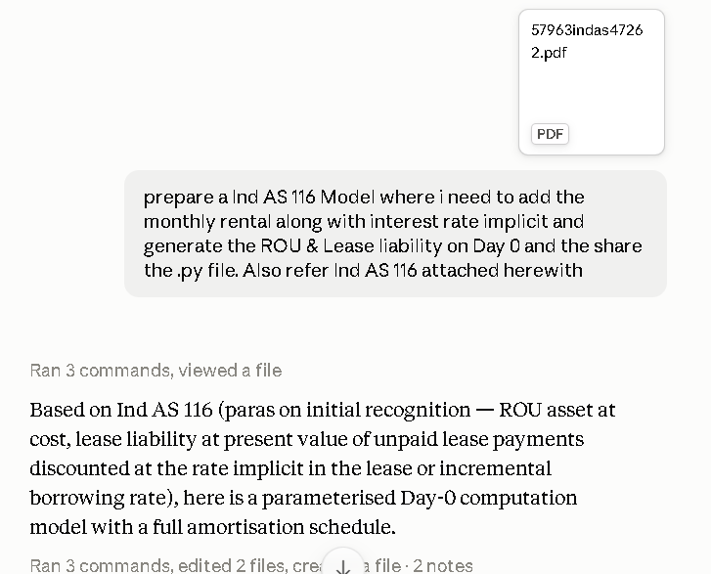
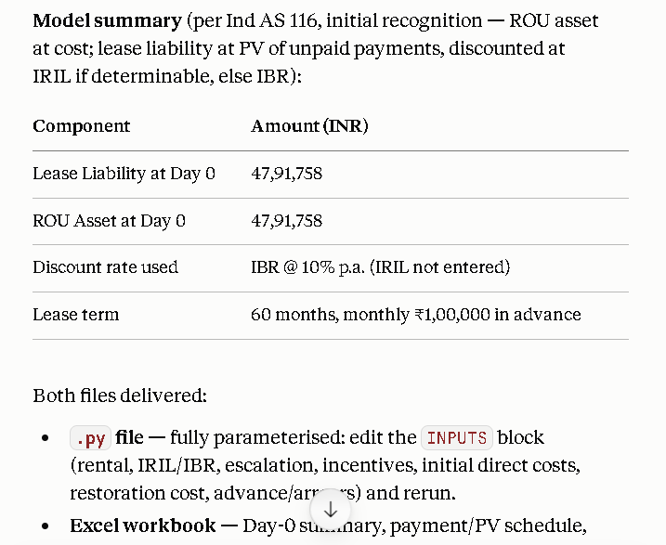

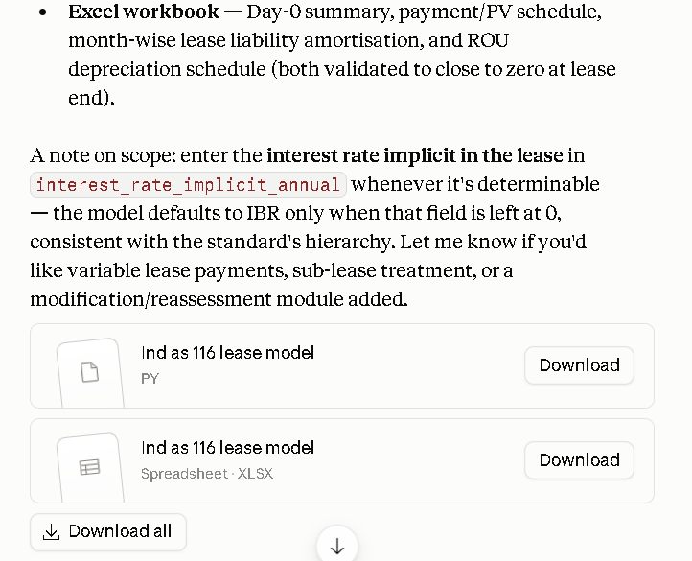
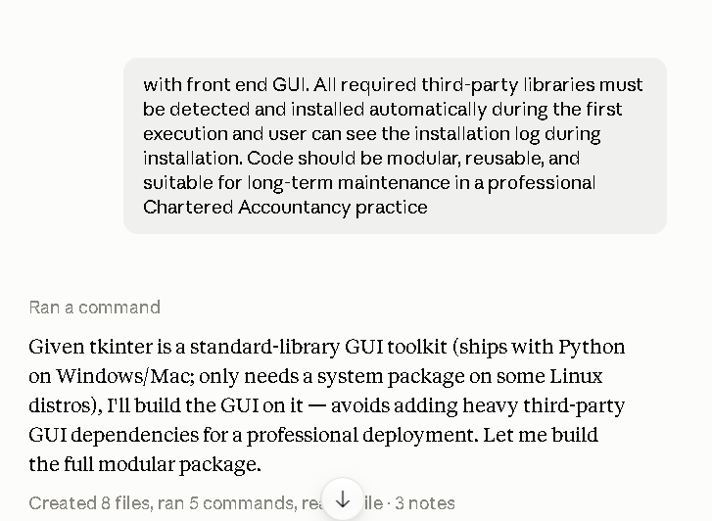

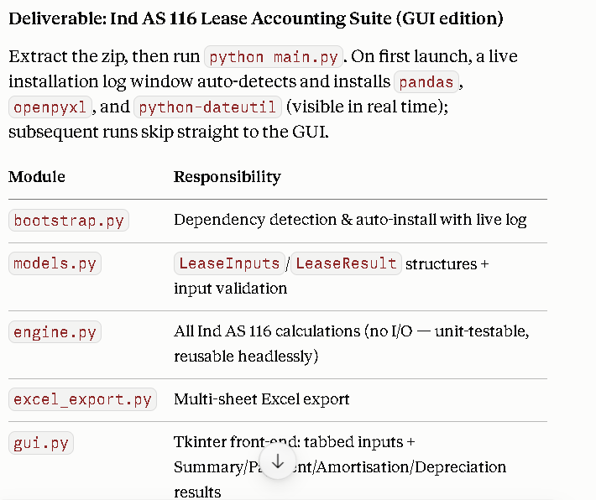

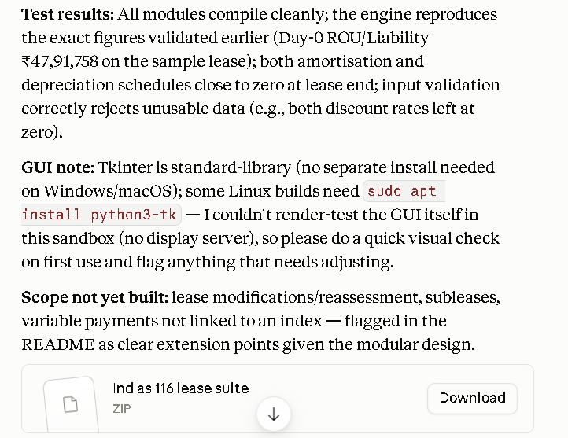

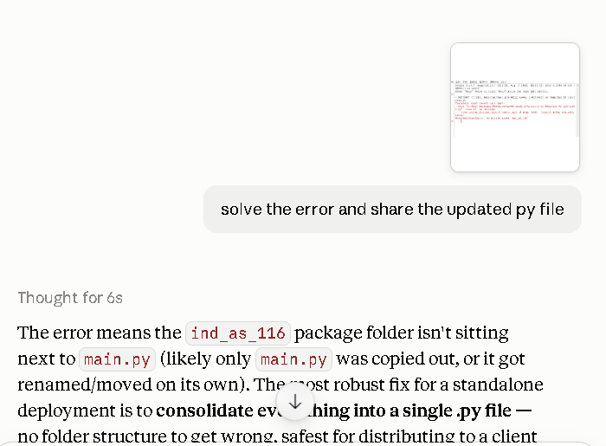

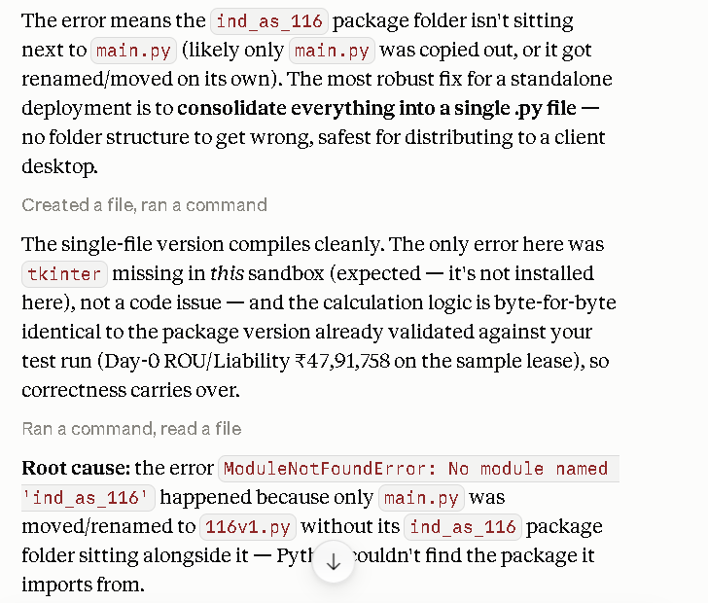
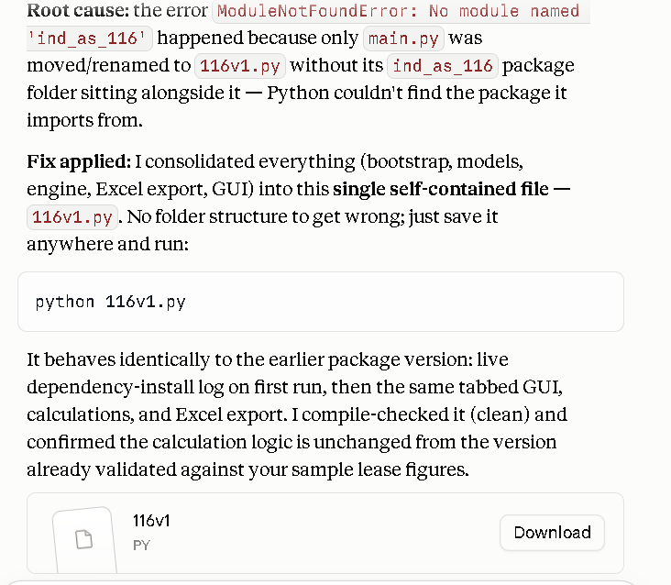

Last step Prepare executive application

Step 1 - C:\Abhi Personal\Resource\AICAI Level 2\Ind AS 116\ind_as_116_suite
Step 2 -CMD
Step 3 -python -m PyInstaller --onefile --noconsole 116v1.py

File is ready with Application extension

